Material Safety Data for Aqua Regia

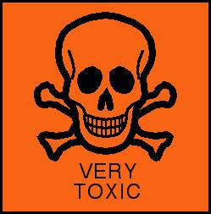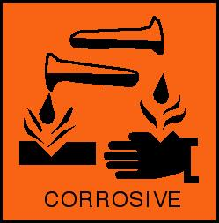

General:
A mixture of concentrated hydrochloric acid and concentrated nitric acid in a molar ratio of 3 to 1.
Synonyms: nitrohydrochloric acid
Molecular Formula: HCl + HNO3
CAS No: 8007-56-5 (20-05-01)
Physical Data:
Appearance: red, yellow or gold fuming liquid
Melting point:
Boiling point:
Vapor density:
Vapor pressure:
Density (g cm-3):
Flash point:
Explosion limits:
Autoignition temperature:

Stability:
Pressure will develop in sealed bottles. Incompatible with (and may react violently with) a wide variety of materials, including metals, oxidizing agents, reducing agents, and combustible materials.

Toxicology:
Highly toxic. Extremely corrosive. May be fatal if swallowed or inhaled. Causes severe burns in contact with skin. Causes severe eye damage on contact. Serious respiratory irritant.

Risk Phrases:
R21 R26 R28 R34 R41.

Transport Information:
Not transportable as a mixture. Requirement for vented containment due to progressive gas generation and inherent instability renders this formulation non-shippable.

Personal Protection:
Safety glasses, gloves, good ventilation. Do not use before a risk assessment has been prepared.

